NAME: SAGARSUMAN P MANJHI SUBJECT: PYTHON PROGRAMMING LAB | PRACTICAL: 12 | BATCH : 04  SYBVOC :SEM-III (DS)
EXPERIMENT BASED ON DATABASE CONNECTIVITY (SQLITE/MYSQL/EXCEL)

AIM : To study and implement database connectivity in Python by developing a Student Details System that performs Create, Read, Update, and Delete (CRUD) operations using an Excel workbook as the data store with the openpyxl library
LEARNING OBJECTIVE :
  - To understand data storage and database connectivity concepts in Python.
  - To create and manage student records using Python.
  - To perform Create, Read, Update, and Delete (CRUD) operations.
  - To read and write student data using Excel files.
  - To use the openpyxl library for workbook operations.
  - To validate student details and prevent duplicate roll numbers.
  - To implement a menu-driven application using functions and conditional statements
TOOLS :
Sr. No. | Name Of Resources | Specification | Quantity | Remarks
1. | Hardware | Computer (i5-i7) Ram (Min 16GB) | 1 | For All Practical
2. | Software | Python / IDLE / VS Code | 1 | For All Practical
THEORY :
Database connectivity allows a Python application to store, retrieve, modify, and delete records from a data storage system. CRUD represents the four basic operations used to manage records.
In this practical, a menu-driven Student Details System is developed using Python and the openpyxl library. Student records are stored in an Excel workbook named student_details.xlsx, with columns for roll number, name, course, and age.
Concepts Used
- CRUD Operations: Create, Read, Update, and Delete student records.
- Excel Workbook: Stores student information in a spreadsheet file.
- openpyxl: A Python library used to read and modify Excel .xlsx files.
- Workbook(): Creates a new Excel workbook.
- load_workbook(): Opens an existing Excel workbook.
- append(): Adds a new row to a worksheet.
- iter_rows(): Iterates through worksheet rows.
- delete_rows(): Deletes a row from a worksheet.
- Input Validation: Checks that required fields are filled and age is a positive integer.
- Duplicate Checking: Prevents adding a student with an existing roll number.
- Menu-Driven Programming: Allows users to select an operation from a numbered menu.
Important: Although the experiment title mentions SQLite/MySQL, the supplied program uses an Excel workbook, not a relational database. It demonstrates CRUD concepts and file-based data management using openpyxl.
Source Code:
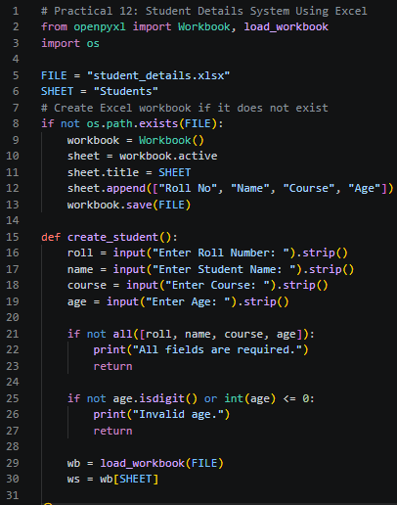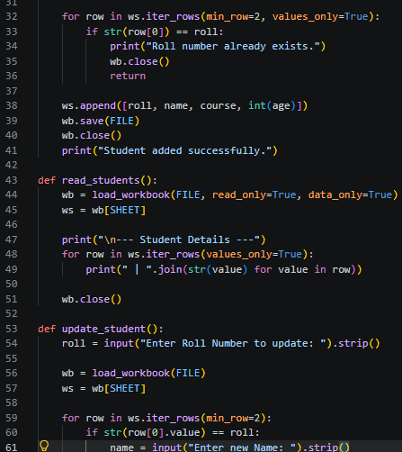
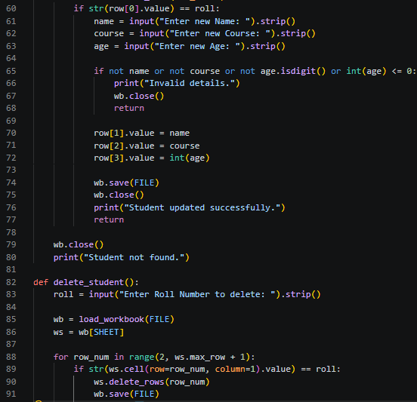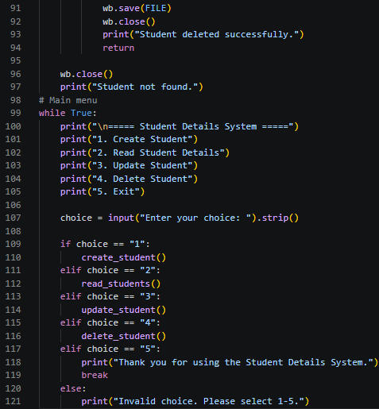

Output:
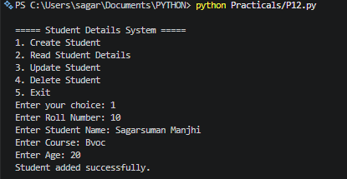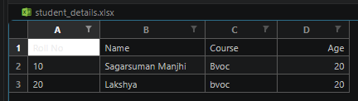
Result and Discussion:
The Student Details System was implemented successfully using Python and the openpyxl library.
The application provides a menu to create, read, update, and delete student records. Student details are stored in an Excel workbook named student_details.xlsx. The program validates required fields, checks that age is a positive integer, and prevents duplicate roll numbers during record creation.
The workbook allows student records to remain available between program executions. However, this is an Excel-based solution rather than a true SQLite/MySQL database implementation.

Learning Outcomes:
- Learned to create and manage student records using Python.
- Understood the four CRUD operations.
- Used openpyxl to create, read, update, and delete spreadsheet records.
- Applied input validation and duplicate roll-number checking.
- Developed a menu-driven application using functions and loops.
- Understood the difference between spreadsheet-based storage and relational database connectivity.
Course Outcomes:
- Understand data storage and CRUD operations in Python.
- Apply functions and conditional statements to manage records.
- Use Python libraries to read and write structured data.
- Develop a menu-driven student management application.
CONCLUSION :
The Student Details System was developed successfully using Python and Excel workbook operations. It supports creating, reading, updating, and deleting student records, validates user input, and prevents duplicate roll numbers. The practical demonstrates CRUD concepts and structured data management. To meet the database-connectivity requirement strictly, the program can be adapted to use SQLite or MySQL instead of Excel.

VIVA QUESTIONS :

Q1. What does CRUD stand for?
CRUD stands for Create, Read, Update, and Delete.
Q2. What is database connectivity?
Database connectivity allows a program to interact with a data storage system to store, retrieve, and modify information.
Q3. What is openpyxl?
It is a Python library used to read and modify Excel .xlsx files.
Q4. What is the purpose of Workbook()?
It creates a new Excel workbook.
Q5. What does load_workbook() do?
It opens an existing Excel workbook.
Q6. Why is the os module used?
It checks whether the Excel file already exists before creating a new workbook.
Q7. How does the program prevent duplicate student records?
It checks existing roll numbers before adding a new record.
Q8. What is the purpose of append()?
It adds a new row to the worksheet.
Q9. Are Excel and SQLite the same?
No. Excel is spreadsheet software, whereas SQLite is a relational database engine that stores data in database tables.
Q10. Does the program permanently store student records?
Yes. The records are saved in student_details.xlsx and remain available after the program closes, unless the file is deleted or modified.

FOR FACULTY USE ONLY :
Correction Parameters | Formative Assessment [40%] | Timely completion of practical [40%] | Attendance/ Learning Attitude [20%]
Marks Obtained

